**DAILY ONLINE ACTIVITIES SUMMARY**

|  |  |  |  |  |  |  |  |  |
| --- | --- | --- | --- | --- | --- | --- | --- | --- |
| **Date:** | **19-05-2020** | | | | | **Name:** | **Sneha K Bakale** | |
| **Sem & Sec** | **6th B** | | | | | **USN:** | **4al17cs095** | |
| **Online Test Summary** | | | | | | | | |
| **Subject** | | **CGV** | | | | | | |
| **Max. Marks** | | **60** | | **Score** | | | **55** | |
| **Certification Course Summary** | | | | | | | | |
| **Course** | **Computer vision essentials** | | | | | | | |
| **Certificate Provider** | | | **Great learning Academy** | | **Duration** | | | **1 week** |
| **Coding Challenges** | | | | | | | | |
| **Problem Statement: Given programs** | | | | | | | | |
| **Status: Completed** | | | | | | | | |
| **Uploaded the report in Github** | | | | | **Yes** | | | |
| **If yes Repository name** | | | | | **https://github.com/Sneha35/OnlineCourse-And-Coding.git** | | | |
| **Uploaded the report in slack** | | | | | **Yes** | | | |

Online Test Details: (Attach the snapshot and briefly write the report for the same)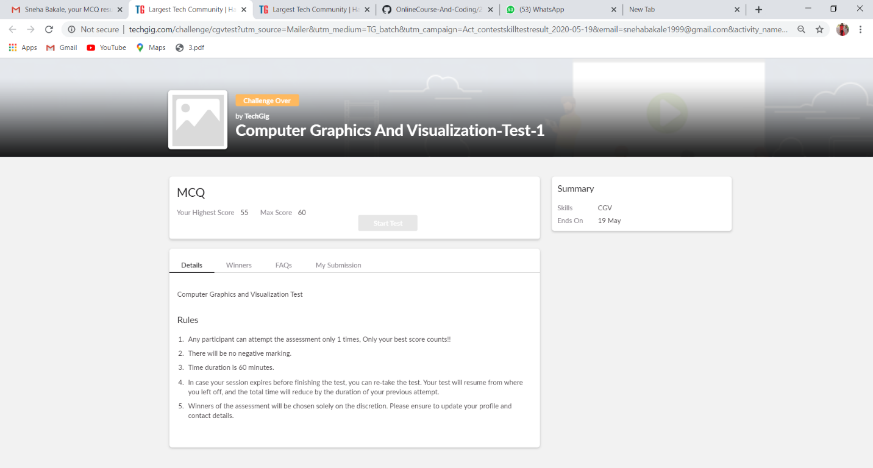

Certification Course Details: (Attach the snapshot and briefly write the report for the same)

Coding Challenges Details: (Attach the snapshot and briefly write the report for the same)